EXP. NO: 16 SIMULATION AND ANALYSIS OF UNIFORM AND NON-UNIFORM
QUANTIZATION USING MATLAB

NAME:V.RUSHMITHA
DATE:09/10/2026
Objectives
i) To implement and analyze uniform and non-uniform quantization techniques for an analog
signal using MATLAB by converting the continuous-amplitude signal into discrete
quantization levels.
ii) To compare the performance of uniform and non-uniform quantization by analyzing their
quantized waveforms and quantization errors, and evaluate their effectiveness in representing
signals with different amplitude variations.
Procedure
1. Open MATLAB and create a new script file.
2. Define the simulation parameters, including the sampling frequency, time vector, signal
amplitude, signal frequency, and the number of quantization levels.
3. Generate the analog input signal using a sinusoidal waveform.
4. Implement uniform quantization by dividing the signal amplitude range into equal quantization
intervals and obtain the uniformly quantized signal.
5. Calculate the quantization error by finding the difference between the original analog signal and
the uniformly quantized signal.
6. Implement non-uniform quantization using a companding technique (such as μ-law or A-law)
followed by quantization.
7. Recover the non-uniformly quantized signal by applying the corresponding expansion process.
8. Calculate the quantization error for the non-uniform quantized signal.
9. Plot the original analog signal, uniformly quantized signal, non-uniformly quantized signal,
uniform quantization error, and non-uniform quantization error using MATLAB subplots.
10. Compare the performance of uniform and non-uniform quantization by analyzing the quantized
waveforms and the corresponding quantization errors.
11. Evaluate the effectiveness of both quantization techniques in representing signals with different
amplitude variations.
12. Interpret the simulation results and conclude the advantages of non-uniform quantization over
uniform quantization for low-amplitude signals.
PROGRAM (MATLAB CODE)
clc;
clear;
close all;
% Input Signal
t = 0:0.001:1;
x = sin(2*pi*5*t);
% Uniform Quantization (8 Levels)
L = 8;
x_uni = round((x+1)*(L-1)/2); x_uni = (x_uni*2/(L-1))-1;
% Non-Uniform Quantization (μ-law)
mu = 255;
x_comp = sign(x).*log(1+mu*abs(x))/log(1+mu);
x_non = round((x_comp+1)*(L-1)/2);
x_non = (x_non*2/(L-1))-1;
% Plot Results
figure;
subplot(3,1,1)
plot(t,x)
title('Original Signal')
grid on
subplot(3,1,2)
stairs(t,x_uni)
title('Uniform Quantization')
grid on
subplot(3,1,3)
stairs(t,x_non)
title('Non-Uniform Quantization (\mu-law)')
grid on
OUTPUT GRAPH
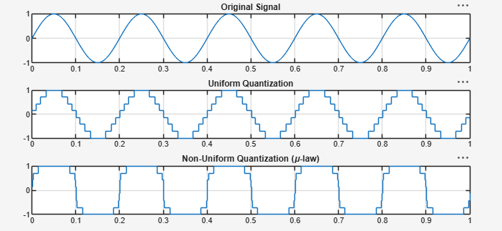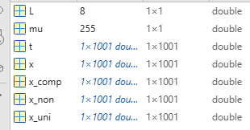

Result:
i) The uniform and non-uniform quantization techniques were successfully implemented in
MATLAB, and the corresponding quantized signals and quantization error waveforms were
obtained.
ii) The performance comparison showed that non-uniform quantization produced lower
quantization error for low-amplitude signals than uniform quantization, resulting in improved
signal representation and better overall quantization efficiency.

